**Week 3 day 6 (27-11-2024)**

**Today’s Topics:**

* **Azure DataBricks Setup**
* About Azure DataBricks:
  + Different Services
  + Many other concepts
* **Creating Compute clusters**
* Code implementations in new cluster (from case study)
* **Azure DataBricks Setup:**

1. Login with the credentials (Entra account with ID and password) - <https://drive.google.com/file/d/1FxJ1YWdNiBOzhvJREcq3xJhzULZfb4ci/view?usp=drive_link>

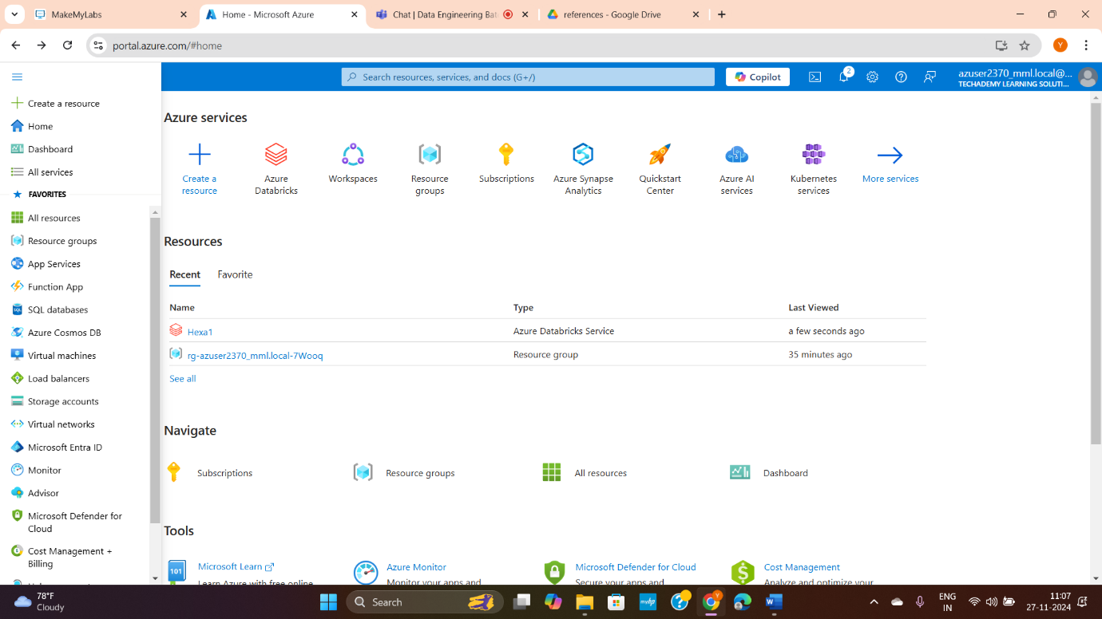

Click all services to explore multiple azure services. (If needed)

1. Go to resources (is created by organisation where you will get access to create and use some azure resources like DataBricks)
2. From there search for DataBricks and click create.

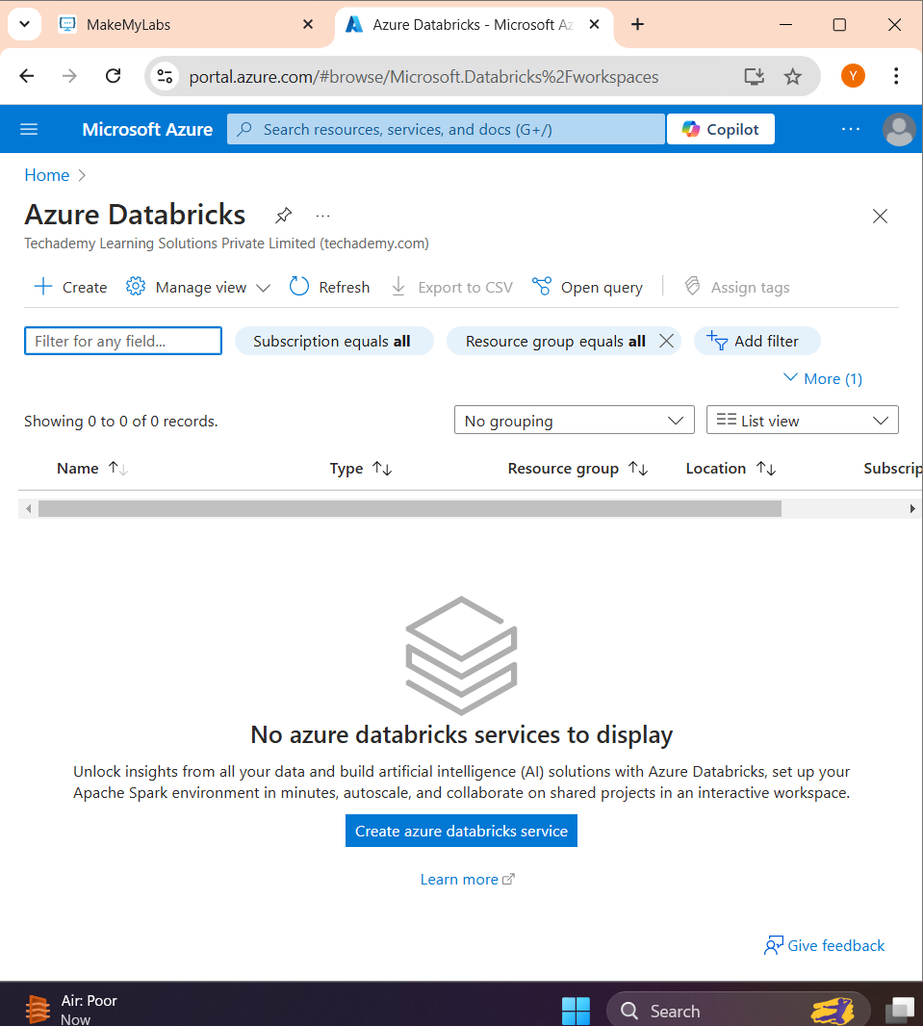

1. Give details and click review + create.

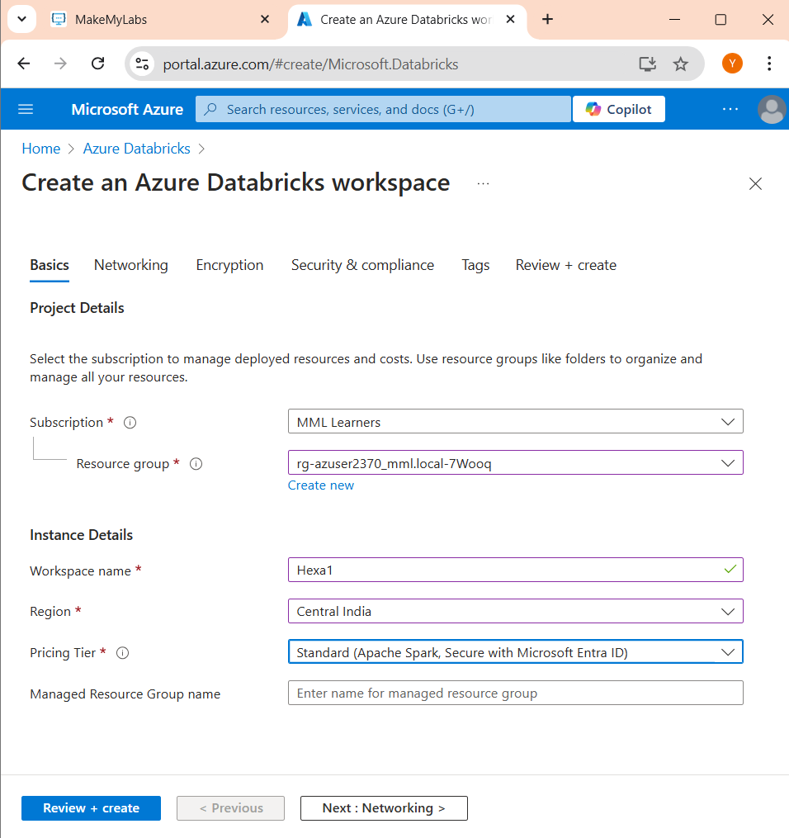

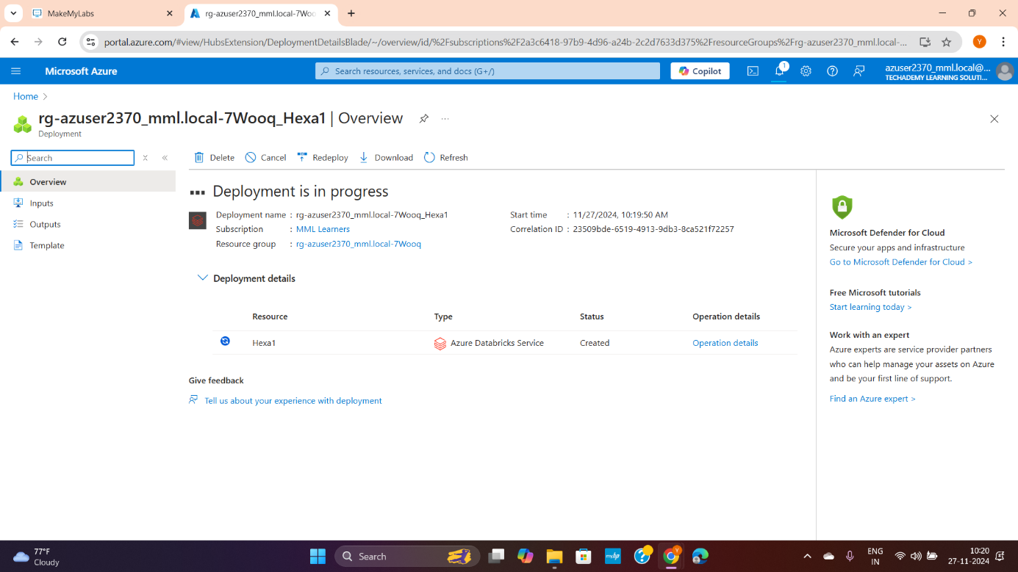

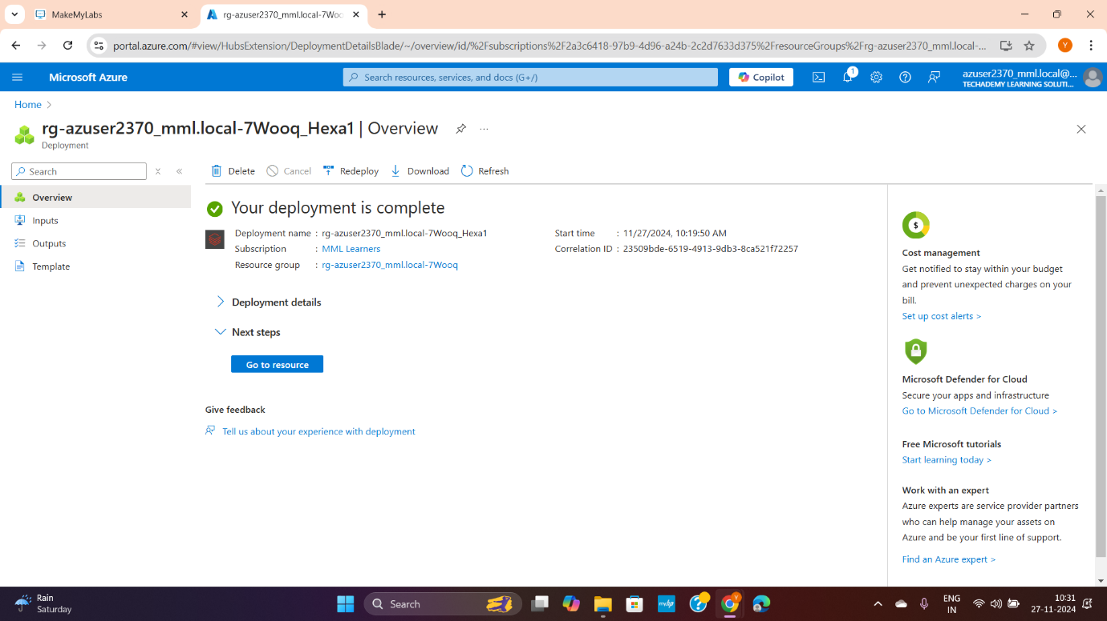

1. Go to Resources

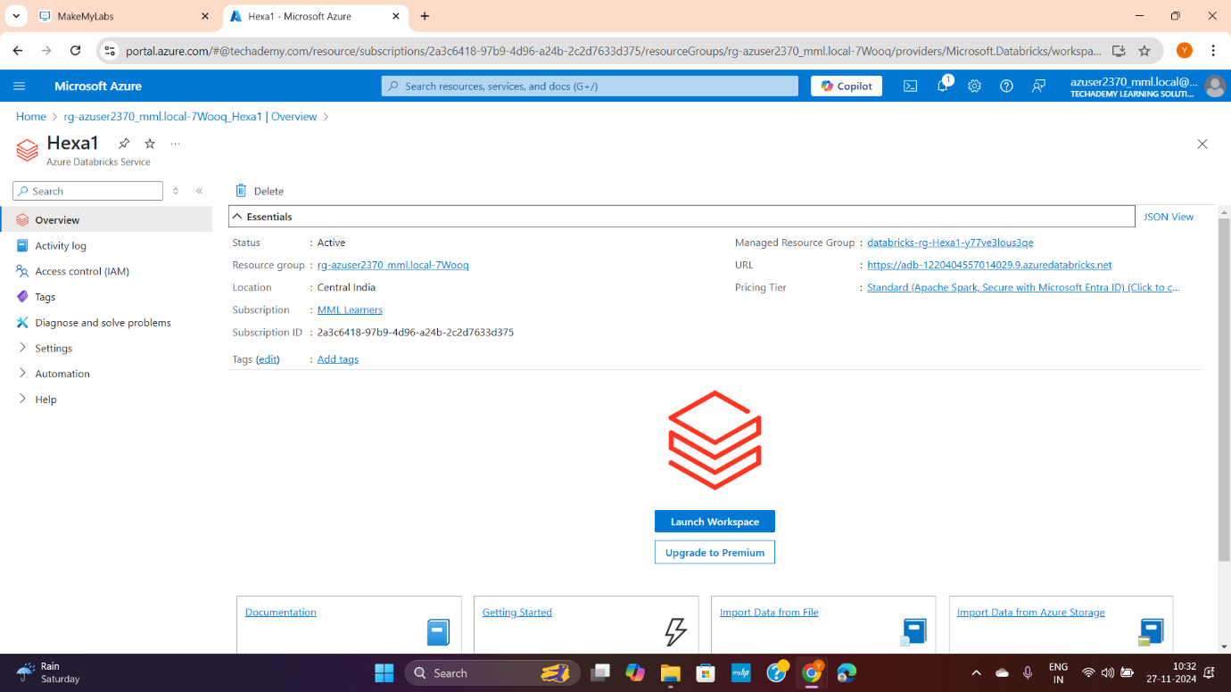

1. Click the URL in above image and login with Entra credentials. Finally You got your Azure data bricks.

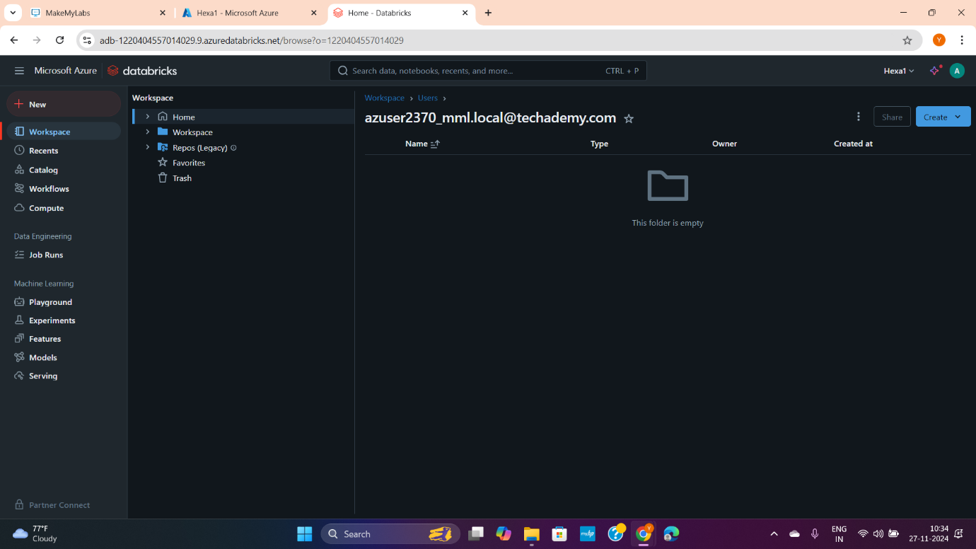

* **About Azure DataBricks:**
  + **Different Services**

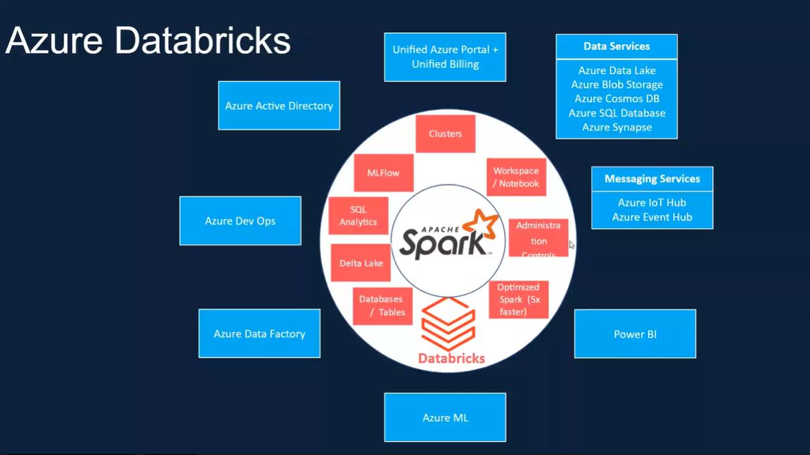

* + **Also refer the ppt**
    - Premium vs standard package advantages
    - Cluster architecture (worker)
    - Types of configurations bases on clusters (Single – 1 main node 2 worker nodes, multi-mode)
    - Types of run time available in cluster
    - Cluster time 10 to 10,000 mins duration
    - Price calculations for different packages (based on DBU, extra workers cost etc.)
    - How to control cost
* **Creating Compute clusters:**

